Blood Bank Management System Project

Second Sprint Backlog
and Status

Sprint 2 Backlog :

User Login and Authentication:
- Create login page for all user types (admin, donor, hospital, organization)(Completed)
- Validate user credentials on login(Completed)
- Handle login errors and display appropriate messages(Completed)
- Store JWT token in the client-side securely (e.g., localStorage or cookies)(Completed)

User Logout and Authentication:
- Implement logout functionality on the frontend(Completed)
- Invalidate JWT token on logout(Completed)
- Redirect users to the login page upon logout(Completed)
- Ensure secure token storage and invalidation(Completed)
- Handle session expiration and token renewal(Completed)

Frontend for Inventory Management:
- Create inventory dashboard for viewing inventory status(in Progress)
- Implement inventory list view with search and filter options(in Progress)
- Develop forms for adding new inventory items(in Progress)
- Develop forms for updating existing inventory items(in Progress)
- Implement delete functionality for inventory items( in Progress)
- Display inventory details (e.g., blood type, quantity, expiration date)( in Progress)
- Implement pagination for large inventory lists( in Progress)
Role-Based Access Control:
- Define roles and permissions for different user types (admin, donor, hospital, organization)(Completed)
- Implement middleware on the backend to check user roles and permissions(Completed)
- Restrict access to certain routes based on user roles(Completed)
- Display different UI elements based on user roles (e.g., admin sees more options than a donor)(in Progress)

We have completed middleware and backend part of web App Front-end we have started dashboard for inventory blood bank. Will be completed in sprint 3
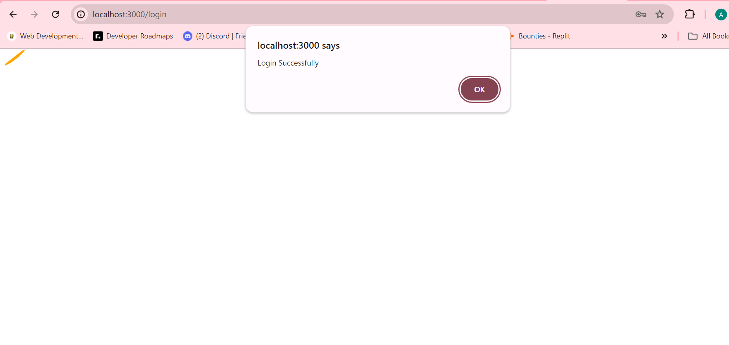
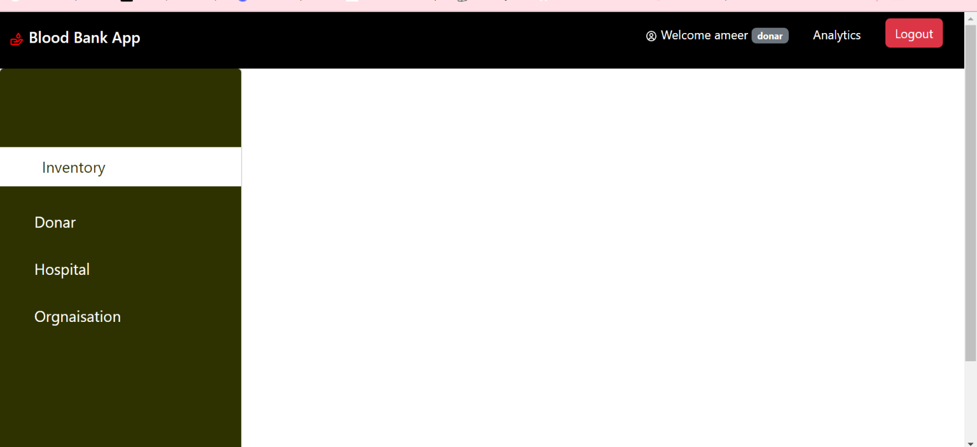

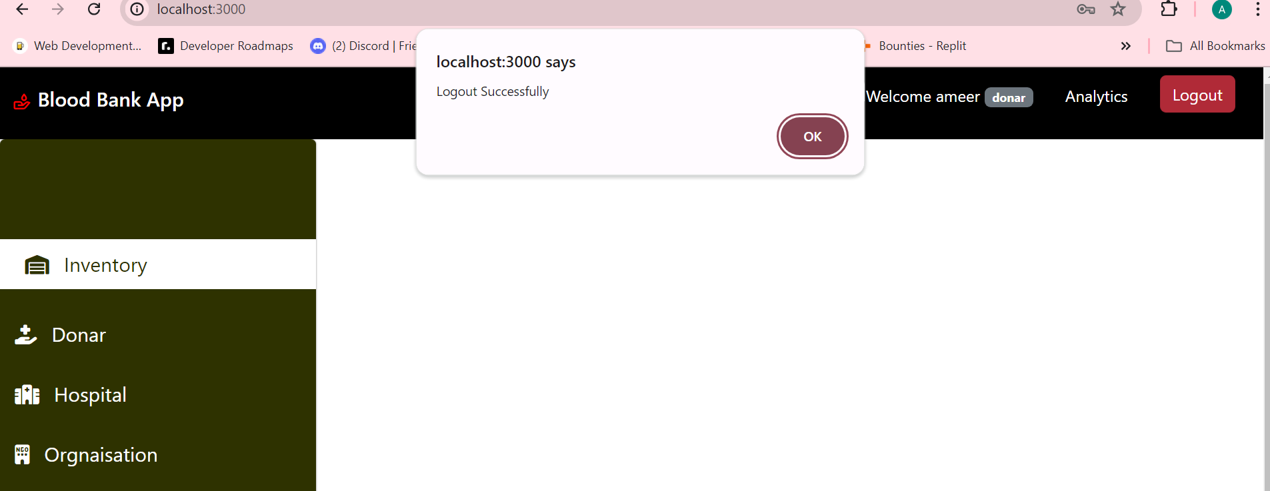

Sprint 3 Backlogs:

- UI Elements:
  - Donor Records:
    - Display donor information
    - Allow editing of donor records
    - Implement search and filter options for donor records
  - Admin Dashboard:
    - Display summary of inventory status
    - Show recent activities and notifications
    - Provide quick links to manage users and inventory
  - Hospital Records:
    - Display hospital information
    - Allow editing of hospital records
    - Implement search and filter options for hospital records
  - Blood In and Out:
    - Display blood donation and usage records
    - Implement forms for recording blood donations and usage
    - Provide detailed view and search options for blood transactions
- Donation Management:
  - Scheduling and managing blood donations:
    - Implement functionality to schedule blood donation appointments
    - Manage and track donation appointments
  - Tracking donation history:
    - Display donation history for users
    - Allow users to view their past donations
- Reporting and Analytics:
  - Generate reports for blood inventory:
    - Create reports summarizing blood inventory status
  - Dashboard for user activities and inventory status:
    - Implement a dashboard to visualize user activities and inventory metrics
- Testing and Deployment:
  - Unit and integration testing:
    - Develop and execute unit tests for all components
    - Perform integration testing to ensure components work together
  - Continuous deployment and integration setup:
    - Set up continuous integration and deployment pipelines
    - Automate testing and deployment processes to streamline updates

----------------------------------------------------------------------------------------------

